**Step 1: Work Station Set Up (General Principles)**

* Find a comfortable chair with back support ensuring your feet are supported
* Use a hard flat surface such as a table or desk
* Position your monitor about an arm’s length away
* The top of your screen should be at or slightly below eye level with your neck straight
* Relax shoulders and arms at your side with elbows at 90 degrees and wrists straight
* Try to find a designated spot for your work, separating work from home life if possible
* Take time to set up your work station optimally (see image) when you transition between positions

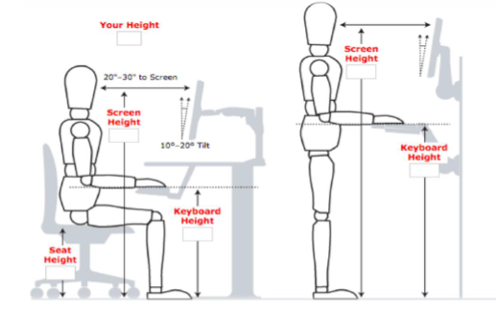

**Step 2: Home work station solutions**

**You can modify and improve your work station at home as follows:**

**Are your feet supported (flat on the floor)?**

* Place something firm under your feet so knees are bent at approximately 90 degrees
* Use shoe boxes or a storage box under your feet if needed

**Is your chair too low?**

* Try different chair heights. The ideal seat height is at or slightly below knee level.
* Place a cushion or towel on your seat to raise you up
* Avoid sitting on stools or couches while working

**Is your lower back curve supported?**

* Roll up a towel and place it into the curve of your lower back

**Is your keyboard too high?**

* Try different table tops or flat work surfaces so the keyboard is around elbow height
* Use an external keyboard and/or mouse to help with height adjustments
* Place a cushion or towel on your seat to raise you up

**Is your monitor too low?**

* Use books, shoe boxes or a cake pan to raise your monitor height if you find you are looking down
* Use your TV as a monitor (if working with a laptop)
* If you are using 2 monitors, center yourself between the monitors and raise both

**Are your hands, wrist and forearm in line?**

* Keep your keyboard and mouse just below your elbow, with arms close to your body
* Make sure you have enough surface area to manoeuvre the mouse

**Straining your eyes?**

* Adjust monitor distance or enlarge your font size to help reduce eye strain
* Adjust lighting sources and screen brightness to reduce glare
* Stay hydrated and take breaks from screen time

**Step 3: Take movement breaks and connect with others**

* Make frequent positional changes. Vary your posture at least every 30 minutes.
* Take breaks and fit in movement or gentle stretches throughout the day (see image)*
* Set reminders to plan time for task changes, breaks or stretches
* Try to maintain a regular exercise routine
* 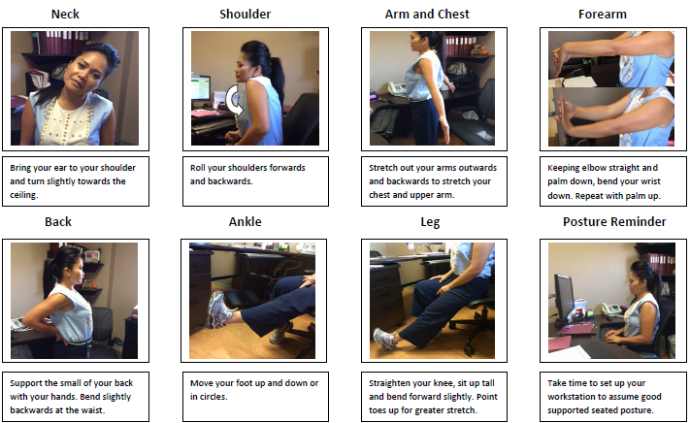Stay connected with your colleagues. Check-in with each other and offer support when appropriate

Discuss stretching options with your health care provider as appropriate. Image source: Sunnybrook Health Science Centre

Any questions? Contact Chimine Li, Occupational Safety Specialist at [chimine.li@hollandbloorview.ca](mailto:chimine.li@hollandbloorview.ca)

or Kaley Carveth, Occupational Health Nurse at kcarveth@hollandbloorview.ca



Below is a link to an additional resource for viewing at your leisure – a 20 minute ergonomics webinar on working from home from Humantech.

<https://info.humantech.com/Working-from-Home_leh-Video.html?aliId=eyJpIjoiOGY1NFNhKzBJK1Y5Y1N3dCIsInQiOiIwR3ZvQTBnTzhEZVBpMU5hekNhNThRPT0ifQ%253D%253D>